Digits Mastery Assignment
Reflection Log
Stefan S
CSE 2140 2nd Language Programming
(Digits2.java)
How has your program changed from planning to coding to now? Explain.
My program started as a copy paste of my Digits assignment.
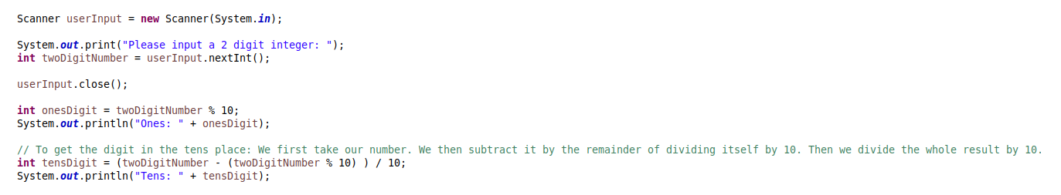

There was some trial and error. I discovered that this operation gives me the hundreds place digit, rather than the 10s place, for example.
This program was rather simple to make. Mostly because I had already written the code. It could be much more elegant, but I don’t have the time.
I also regret not being able to add try-except loops (for if the user puts a float as the input, for example), but once again. I’m under a time crunch and I don’t have the java knowledge yet.
The program can ONLY handle numbers that are three digits or less. I would do more if I had the time.

